THE ULTIMATE 5S IMPLEMENTATION GUIDE
Transform Your Workplace into a Brighter, Shiner, Safer & More Productive Environment Your Partner in Sustainable Workplace Transformation
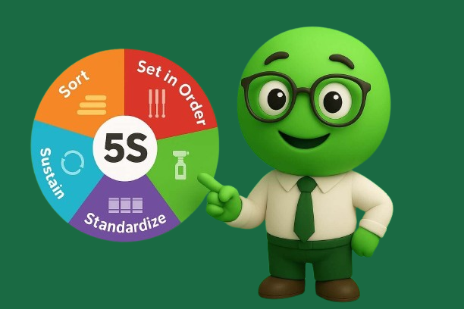
Contents
- Why 5S Matters for Your Business 4
- The Hidden Costs of Workplace Disorganization 4
- Common Warning Signs Your Company Needs 5S 5
- Understanding the 5S Methodology 5
- Step-by-Step Implementation Guide 6
- 5. Industry-Specific Applications 8
- Sustaining 5S: The Key to Long-Term Success 10
- Greendot's Proven Sustainability Framework 10
- ROI Calculator & Measurement Tools 11
- Measurement Dashboard Template 11
- Common Implementation Mistakes to Avoid 12
- Ready-to-Use Templates & Checklists 13
- Weekly Implementation Schedule 14
- 5S Audit Checklist Template 14
- Red Tag Template 15
- Client Success Stories 17
- Ready to Get Started? 18
- Next Steps: 18
- Conclusion 18
- About Greendot Management Consultants 19

Why 5S Matters for Your Business

What is 5S?
5S is a Japanese workplace organization methodology that creates and maintains a clean, organized, and efficient work environment. The name comes from five Japanese words:
- Seiri (Sort)
- Seiton (Set in Order)
- Seiso (Shine)
- Seiketsu (Standardize)
- Shitsuke (Sustain)

Why SMEs Need 5S More Than Ever
Research shows that employees in disorganized workplaces spend up to 30% of their time searching for tools, documents, and materials. For a company with 50 employees earning an average of ₹50,000/month, this translates to ₹7.5 lakhs in lost productivity every month.
Key Benefits for Your Organization
- Immediate productivity gains of 15-30%
- Reduction in workplace accidents by up to 70%
- Inventory accuracy improvement of 25-40%
- Employee satisfaction increase of 20-35%
- Setup/changeover time reduction of 50-75%

The Hidden Costs of Workplace Disorganization
Financial Impact Analysis
Problem Area | Cost Impact | Annual Loss (50-employee company)
Time wasted searching | 2-3 hours/employee/day | ₹18-27 lakhs
Duplicate purchases | 5-10% of inventory | ₹2-5 lakhs
Workplace accidents | Insurance + downtime | ₹3-8 lakhs
Quality defects | Rework + customer loss | ₹5-15 lakhs
Low employee morale | Turnover costs | ₹4-10 lakhs
**Total Potential Savings |  | ₹32-65 lakhs annually

Common Warning Signs Your Company Needs 5S
- Employees frequently ask "Where is...?"
- Tools and equipment are often missing or misplaced
- Work areas look cluttered and disorganized
- Time spent on setup exceeds actual productive work
- Inventory discrepancies are common
- Workplace accidents occur regularly
- Quality issues arise from wrong materials/tools
- New employees take longer to become productive

Understanding the 5S Methodology
The 5 Pillars Explained

1S - SEIRI (Sort)
Objective: Remove unnecessary items from the workspace
What to Do:
- Identify all items in the work area
- Classify as: Needed daily, weekly, monthly, or never
- Remove items not needed for current operations
- Create a "Red Tag" area for questionable items
Measurable Outcome: Reduce items in workspace by 30-50%

2S - SEITON (Set in Order)
Objective: Organize necessary items for easy access
What to Do:
- Assign specific locations for all tools and materials
- Create visual indicators (labels, color coding, outlines)
- Implement "a place for everything, everything in its place"
- Design efficient workflows and layouts
Measurable Outcome: Reduce search time by 50-70%

3S - SEISO (Shine)
Objective: Clean and inspect the workplace regularly
What to Do:
- Establish cleaning schedules and responsibilities
- Clean equipment, floors, and work surfaces daily
- Inspect for defects, wear, and abnormalities during cleaning
- Address root causes of dirt and contamination
Measurable Outcome: Reduce equipment breakdowns by 25-40%

4S - SEIKETSU (Standardize)
Objective: Create consistent procedures and visual standards
What to Do:
- Document cleaning and organization procedures
- Create visual management systems (charts, photos, instructions)
- Establish audit schedules and checklists
- Train all employees on standards
Measurable Outcome: Achieve 90%+ compliance in audits

5S - SHITSUKE (Sustain)
Objective: Maintain discipline and continuous improvement
What to Do:
- Conduct regular 5S audits and assessments
- Celebrate successes and address non-compliance
- Integrate 5S into daily management routines
- Continuously improve and evolve standards
Measurable Outcome: Sustain improvements for 12+ months

Step-by-Step Implementation Guide

Phase 1: Preparation (Weeks 1-2)
Week 1: Leadership Commitment & Team Formation
Day 1-2:
- Secure leadership commitment and resource allocation
- Form 5S implementation team (5-7 members)
- Select pilot area (recommend starting with 1-2 areas)
Day 3-5:
- Conduct current state assessment
- Take "before" photographs from multiple angles
- Document existing problems and inefficiencies
- Set baseline measurements (time studies, accident rates, etc.)
Week 2: Training & Communication
Day 1-3:
- Train implementation team on 5S principles
- Develop communication plan for all employees
- Create project timeline and milestones
Day 4-5:
- Conduct all-hands awareness session
- Address employee concerns and questions
- Distribute initial 5S materials and guides

Phase 2: Implementation (Weeks 3-8)
Week 3-4: 1S - Sort Implementation
Activities:
- Red tag unnecessary items in pilot area
- Remove obvious clutter and unused items
- Create staging area for questionable items
- Document items removed and space freed
Success Metrics:
- 30-50% reduction in items in workspace
- Clear walkways and emergency exits
- Improved visual access to work areas
Week 5: 2S - Set in Order Implementation
Activities:
- Design optimal layout for remaining items
- Create designated locations for all tools/materials
- Install visual indicators (labels, outlines, color coding)
- Implement shadow boards and tool organization systems
Success Metrics:
- Every item has designated location
- 80% reduction in time to find tools/materials
- Visual indicators are clear and followed
Week 6: 3S - Shine Implementation
Activities:
- Establish cleaning schedules and assignments
- Provide necessary cleaning supplies and tools
- Clean all equipment and work surfaces thoroughly
- Create inspection checklists and procedures
Success Metrics:
- Daily cleaning routines established
- Equipment cleanliness maintained at 90%+ standard
- Early detection of equipment issues increases by 50%

Week 7: 4S - Standardize Implementation
Activities:
- Document all procedures with photos and instructions
- Create visual management boards and displays
- Establish audit schedules and responsibility matrix
- Train all area employees on new standards
Success Metrics:
- 100% of procedures documented and posted
- Visual standards are clear and accessible
- All employees trained and certified
Week 8: 5S - Sustain Preparation
Activities:
- Develop ongoing audit system and scorecards
- Create recognition and accountability systems
- Plan regular review meetings and continuous improvement
- Establish metrics tracking and reporting
Success Metrics:
- Audit system operational and scheduled
- Employee engagement and accountability high
- Management commitment visible and consistent

Phase 3: Sustaining (Ongoing)
Monthly Activities:
- Conduct formal 5S audits using standardized checklists
- Hold team meetings to review progress and address issues
- Recognize achievements and address non-compliance
- Identify opportunities for continuous improvement
Quarterly Activities:
- Comprehensive area assessments and measurements
- Update standards and procedures based on learnings
- Expand 5S to additional areas
- Share best practices across organization

5. Industry-Specific Applications

Manufacturing & Engineering Companies
Typical Challenges:
- Tool and equipment management
- Work-in-process organization
- Maintenance supplies accessibility
- Safety compliance
5S Solutions:
- Shadow boards for tools (2S)
- Kanban systems for inventory (2S)
- Predictive maintenance through cleaning inspections (3S)
- Standard operating procedures (4S)
Expected Results:
- 25-40% reduction in setup times
- 30-50% improvement in equipment availability
- 15-25% increase in overall productivity
- 50-70% reduction in workplace accidents

Chemical & Process Industries
Typical Challenges:
- Chemical storage and identification
- Safety equipment accessibility
- Laboratory organization
- Regulatory compliance
5S Solutions:
- Color-coded chemical storage systems (2S)
- Emergency equipment visibility and access (2S)
- Contamination prevention protocols (3S)
- Documentation and compliance standards (4S)
Expected Results:
- 60-80% improvement in safety compliance
- 20-35% reduction in chemical waste
- 40-60% faster emergency response times
- Improved regulatory audit scores

Service & Office Environments
Typical Challenges:
- Document management and filing
- Digital workspace organization
- Meeting room efficiency
- Customer service areas

5S Solutions:
- Digital and physical filing systems (1S, 2S)
- Standardized workstation setups (4S)
- Meeting room preparation protocols (3S, 4S)
- Customer area presentation standards (3S, 4S)
Expected Results:
- 30-50% reduction in document search time
- 20-30% improvement in meeting efficiency
- Enhanced professional image and customer satisfaction
- 15-25% increase in employee productivity

Sustaining 5S: The Key to Long-Term Success
Why Most 5S Initiatives Fail
Research indicates that 70% of 5S implementations fail within 18 months. Common reasons include:
- Lack of management commitment and follow-through
- Insufficient training and employee engagement
- No systematic audit and measurement system
- Treating 5S as a one-time event rather than ongoing practice
- Failure to address root causes of disorganization

Greendot's Proven Sustainability Framework

1. Management Engagement System
Weekly: Management walkthrough with 5S scorecards Monthly: 5S steering committee meetings Quarterly: Strategic review and improvement planning

2. Employee Accountability Structure
Daily: Self-audits using mobile apps or checklists Weekly: Team huddles with 5S discussions Monthly: Peer recognition and improvement sharing

3. Measurement & Monitoring
Key Performance Indicators (KPIs):
- 5S audit scores (target: 85%+ consistently)
- Time-to-find metrics (target: <2 minutes for any item)
- Safety incident rates (target: 50%+ reduction)
- Employee satisfaction scores (target: 4/5 or higher)
- Productivity measurements (target: 15%+ improvement)

4. Continuous Improvement Integration
- Monthly kaizen events focused on 5S improvements
- Suggestion systems for employee-driven enhancements
- Best practice sharing across departments
- Regular standard updates and evolution

ROI Calculator & Measurement Tools
Quick ROI Assessment Tool

Step 1: Calculate Current Waste Costs
Cost Category | Calculation Method | Your Numbers
Search Time Waste | (Avg. hourly wage) × (Hours spent searching/day) × (Number of employees) × (250 working days) | ₹_______
Duplicate Inventory | (Annual inventory purchase) × (5-10% duplication rate) | ₹_______
Accident Costs | (Average accident cost) × (Number of accidents/year) | ₹_______
Quality Issues | (Rework cost + customer complaints) × (Number of incidents) | ₹_______
Employee Turnover | (Replacement cost per employee) × (Turnover rate) | ₹_______
TOTAL ANNUAL WASTE | Sum of all categories | ₹_______

Step 2: Calculate 5S Implementation Investment
Investment Category | Typical Cost Range | Your Budget
Training & Consulting | ₹2-5 lakhs | ₹_______
Organization Supplies | ₹1-3 lakhs | ₹_______
Visual Management Systems | ₹1-2 lakhs | ₹_______
Employee Time (implementation) | ₹2-4 lakhs | ₹_______
TOTAL IMPLEMENTATION COST | ₹6-14 lakhs | ₹_______

Step 3: Calculate ROI
- Potential Annual Savings: ₹_______ (from Step 1)
- Implementation Investment: ₹_______ (from Step 2)
- ROI Percentage: (Savings ÷ Investment) × 100 = _____%
- Payback Period: Investment ÷ (Monthly Savings) = ____ months

Measurement Dashboard Template
Daily Metrics (5-minute check)
- Work area cleanliness score (1-10)
- Tools in designated locations (% compliance)
- Safety equipment accessible (Yes/No)
- Documentation up-to-date (Yes/No)
Weekly Metrics (15-minute assessment)
- Formal audit score using 5S checklist
- Employee feedback and suggestions collected
- Time-to-find measurements for key items
- Progress photos and visual documentation
Monthly Metrics (comprehensive review)
- Overall 5S performance score
- Cost savings calculations and tracking
- Employee satisfaction survey results
- Continuous improvement actions implemented

Common Implementation Mistakes to Avoid
Top 10 5S Implementation Pitfalls

1. Starting Too Big
Mistake: Attempting to implement 5S across entire facility simultaneously Solution: Start with 1-2 pilot areas, prove success, then expand methodically

2. Inadequate Leadership Support
Mistake: Delegating 5S to middle management without visible executive commitment Solution: CEO/senior leadership must actively participate in audits and reviews

3. Insufficient Employee Training
Mistake: Assuming employees understand 5S concepts without proper education Solution: Invest in comprehensive training for all levels of organization

4. Focusing Only on Housekeeping
Mistake: Treating 5S as just cleaning rather than systematic workplace organization Solution: Emphasize efficiency, safety, and productivity benefits beyond cleanliness

5. No Measurement System
Mistake: Implementing without establishing baseline metrics and tracking progress Solution: Define KPIs, conduct regular audits, and track improvement trends

6. Ignoring Root Causes
Mistake: Addressing symptoms (clutter) without fixing underlying systemic issues Solution: Use problem-solving techniques to identify and eliminate root causes

7. Lack of Standard Operating Procedures
Mistake: Not documenting new processes and expecting informal knowledge transfer Solution: Create detailed, visual SOPs with photos and clear instructions

8. Inadequate Visual Management
Mistake: Relying on memory and verbal communication instead of visual indicators Solution: Implement comprehensive visual management system with labels, colors, and signs

9. No Audit and Accountability System
Mistake: Assuming 5S will sustain itself without regular monitoring and feedback Solution: Establish formal audit schedules, scorecards, and accountability measures

10. Treating as One-Time Project
Mistake: Considering 5S complete after initial implementation Solution: Embed 5S into daily management routine as ongoing operational practice

Ready-to-Use Templates & Checklists
5S Implementation Project Plan Template
Project Charter
Project Name: 5S Implementation - [Area/Department] Project Sponsor: [Name and Title] Project Manager: [Name and Title] Start Date: [Date] Target Completion: [Date]
Objective: Transform [specific area] into organized, efficient, and safe workplace through 5S methodology implementation.
Success Criteria:
- Achieve 85%+ 5S audit scores within 8 weeks
- Reduce search time by 50%+ within 6 weeks
- Maintain improvements for minimum 6 months
- Achieve 90%+ employee satisfaction with changes

Weekly Implementation Schedule
Week | Focus | Key Activities | Success Metrics
1 | Preparation | Team formation, training, baseline assessment | Team trained, current state documented
2 | Communication | All-hands meeting, awareness building | 100% employee awareness achieved
3 | Sort (1S) | Red tag campaign, remove unnecessary items | 30-50% item reduction
4 | Sort completion | Final decisions on red-tagged items | Clear, uncluttered workspace
5 | Set in Order (2S) | Design layout, create designated locations | Everything has a place
6 | Shine (3S) | Establish cleaning routines and schedules | Daily cleaning implemented
7 | Standardize (4S) | Document procedures, create visual standards | SOPs created and posted
8 | Sustain (5S) | Launch audit system, accountability measures | Sustainability system active

5S Audit Checklist Template
Overall 5S Scorecard (Rate each section 1-5, where 5 = Excellent)

1S - SORT (Weight: 20%)
- No unnecessary items in work area (1-5)
- Clear pathways and emergency exits (1-5)
- Only required tools and materials present (1-5)
- Red tag area properly managed (1-5) Subtotal: ___/20

2S - SET IN ORDER (Weight: 20%)
- Everything has designated location (1-5)
- Visual indicators clearly visible (1-5)
- Items returned to proper locations after use (1-5)
- Logical and efficient layout design (1-5) Subtotal: ___/20

3S - SHINE (Weight: 20%)
- Work area is clean and tidy (1-5)
- Equipment properly cleaned and maintained (1-5)
- Cleaning supplies available and organized (1-5)
- Daily cleaning schedules followed (1-5) Subtotal: ___/20

4S - STANDARDIZE (Weight: 20%)
- Procedures documented and visible (1-5)
- Visual standards clearly posted (1-5)
- All employees trained on standards (1-5)
- Consistency across similar work areas (1-5) Subtotal: ___/20

5S - SUSTAIN (Weight: 20%)
- Regular audits conducted and recorded (1-5)
- Issues identified and corrected promptly (1-5)
- Employee engagement and ownership high (1-5)
- Continuous improvement activities active (1-5) Subtotal: ___/20
TOTAL 5S SCORE: ___/100
Scoring Guide:
- 90-100: Excellent - World-class 5S implementation
- 80-89: Good - Minor improvements needed
- 70-79: Average - Several areas need attention
- 60-69: Below Average - Significant improvements required
- Below 60: Poor - Major intervention needed

Red Tag Template
RED TAG - ITEM FOR REVIEW
- Date Tagged: ___________
- Tagged By: ___________
- Item Description: ___________
- Current Location: ___________
- Reason for Tagging:
  - Not needed for current operations
  - Broken or damaged
  - Expired or outdated
  - Duplicate item
  - Wrong location
  - Other: ___________
Recommended Action:
- Dispose/Discard
- Return to proper location
- Repair
- Store elsewhere
- Further evaluation needed
Decision Date: ___________ Action Taken: ___________ Approved By: ___________
Daily 5S Self-Audit Checklist
Employee: ___________ Date: ___________ Area: ___________
Before Starting Work (Rate Yes/No):
- Work area is clean and organized
- All tools and materials in designated locations
- Safety equipment accessible and visible
- Documentation current and available
- Previous day's issues resolved
During Work (Check hourly):
- Returning items to designated locations after use
- Maintaining cleanliness and organization
- Following established procedures
- Identifying and reporting issues promptly
End of Shift (Rate Yes/No):
- Work area cleaned and organized for next shift
- All tools returned to proper locations
- Completed work properly documented
- Any issues reported to supervisor
- Ready for tomorrow's operations
Comments/Suggestions: ___________

Next Steps: Professional Implementation Support
Why Partner with Greendot for 5S Success?
Our Unique Value Proposition
1. Proven Track Record
- 25+ years of consulting experience
- 200+ successful 5S implementations
- 90%+ client satisfaction rate
- Industry expertise across chemical, manufacturing, engineering, and service sectors
2. Sustainability Focus
- Proprietary sustainability framework
- 85% of clients maintain improvements after 24+ months
- Ongoing support and monitoring systems
- Continuous improvement integration
3. Measurable Results
- Average 25-40% productivity improvement
- 50-70% reduction in search time
- 60-80% improvement in safety compliance
- ROI typically achieved within 6-12 months
4. Comprehensive Service Offering
- Initial assessment and gap analysis
- Customized training programs
- Hands-on implementation support
- Audit systems and sustainability tools
- Integration with Lean, TPM, and other methodologies
Typical ROI Achievement:
- 6 months: 150-300% ROI
- 12 months: 400-600% ROI
- 24 months: 800-1200% ROI

Client Success Stories

Case Study 1: Mid-Size Chemical Company (150 employees)
- Challenge: Safety compliance issues, high material waste, inefficient operations
- Solution: Comprehensive 5S implementation across production and laboratory areas
- Results:
  - 70% reduction in safety incidents
  - 40% improvement in material utilization
  - 25% increase in overall productivity
  - ₹45 lakhs annual cost savings

Case Study 2: Manufacturing Company (80 employees)
- Challenge: High setup times, tool management issues, quality problems
- Solution: 5S implementation with focus on tooling and work instructions
- Results:
  - 60% reduction in setup times
  - 85% improvement in tool availability
  - 30% reduction in quality defects
  - ₹25 lakhs annual cost savings.

Ready to Get Started?
Free 5S Assessment Opportunity We're offering a complimentary 2-hour 5S assessment for qualified companies, including:
- Current state evaluation
- Improvement opportunity identification
- ROI potential calculation
- Implementation roadmap outline

Next Steps:
- Download and review this complete guide
- Conduct initial self-assessment using provided tools
- Schedule your free professional assessment
- Develop customized implementation plan
- Begin transformation to brighter, shiner, safer, more productive workplace

Conclusion
5S is not just about cleaning and organizing – it's about creating a foundation for operational excellence, employee engagement, and sustainable business growth. This comprehensive guide provides you with the knowledge, tools, and templates needed to begin your 5S journey.
Remember: The key to 5S success is not just implementation, but sustainability. Focus on building systems, engaging people, and measuring results. With proper approach and support, 5S can deliver transformational results for your organization.
Start small, think big, move fast, and sustain long-term.

About Greendot Management Consultants
greendot is a leading management consulting firm specializing in operational excellence, workplace transformation, and sustainable business improvement. With 25+ years of experience and 11000+ successful implementations, we help companies achieve measurable, lasting results.

Our Services

greendot – Helping SMEs and Mid-Sized Companies Achieve Massive, Sustainable Sales Growth.









Few CLIENTS Of Greendot :



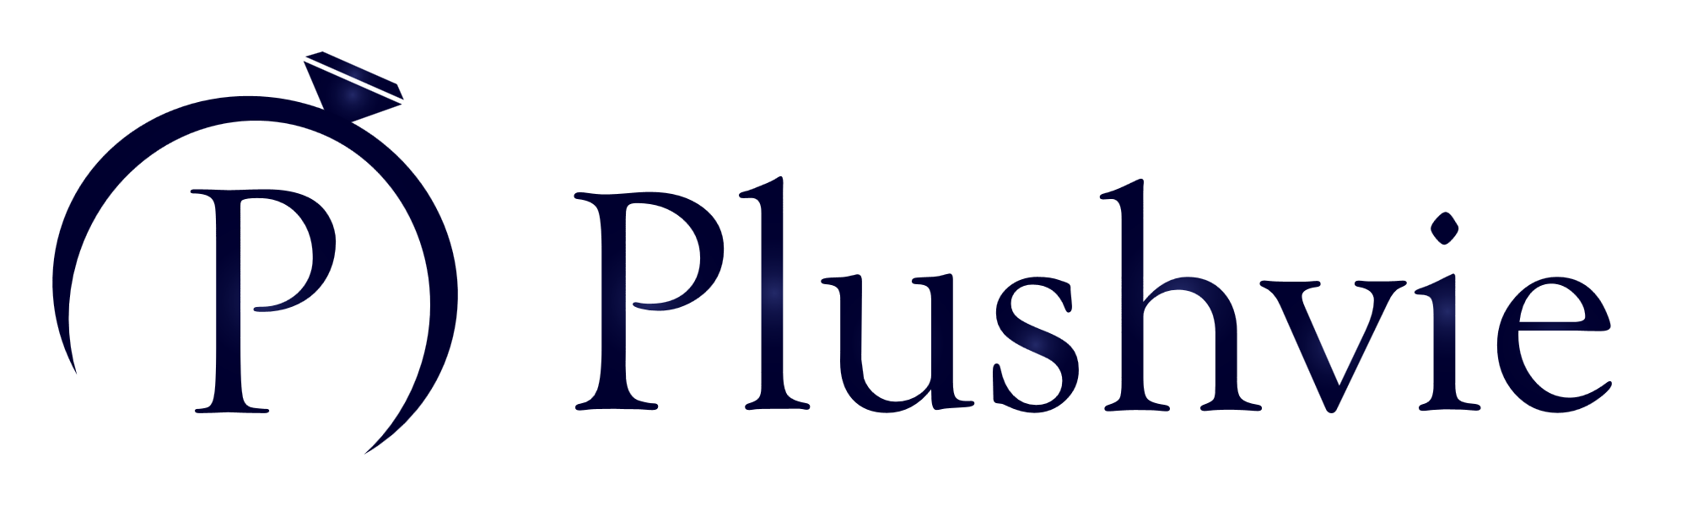


















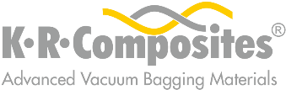



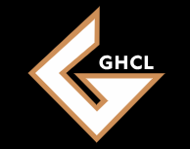

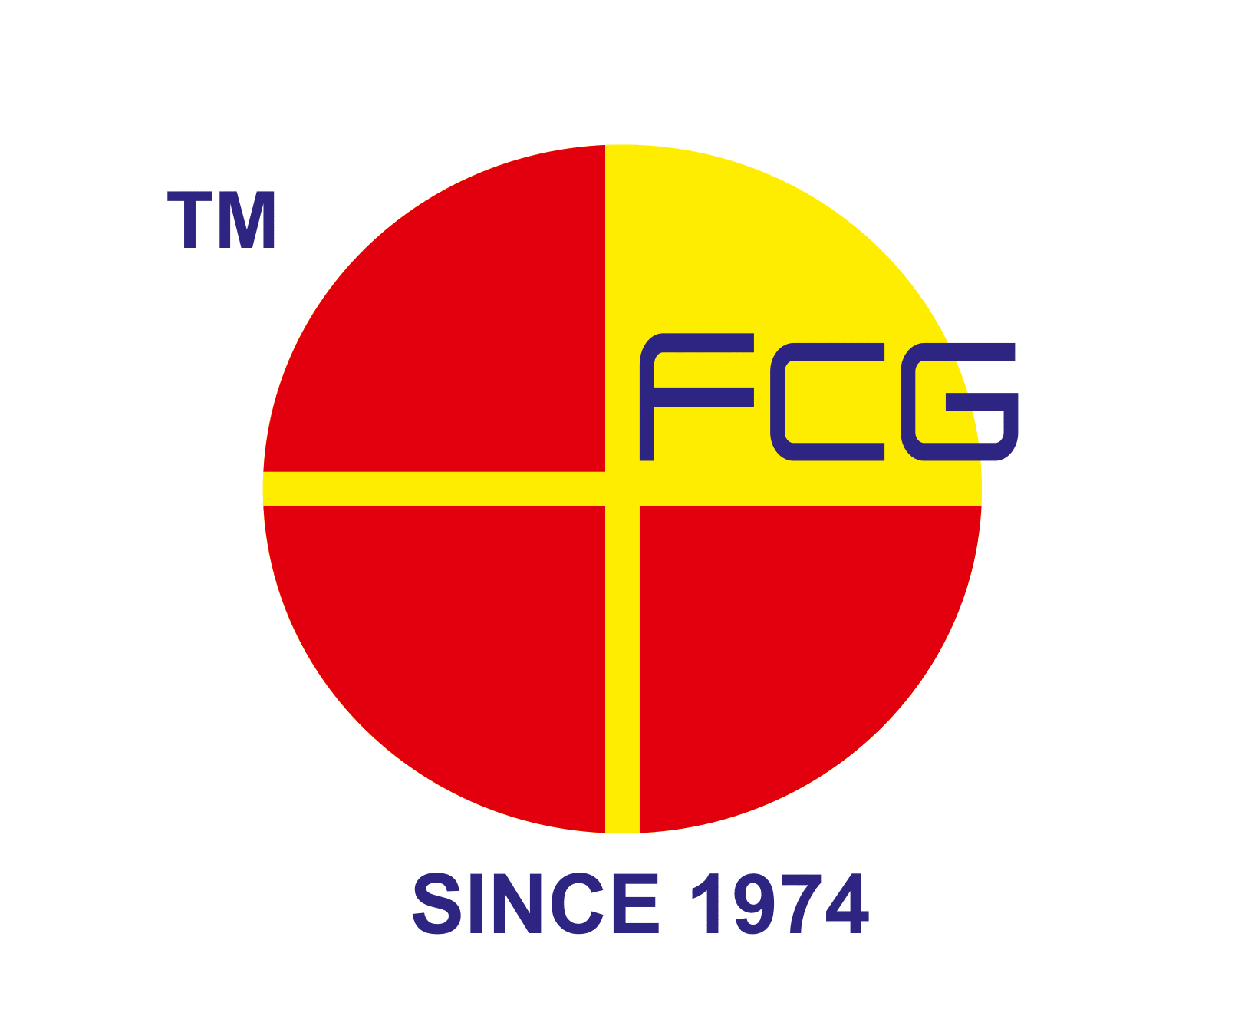











To Schedule Your Free Assessment:
- Email: sales@mygreendot.co.in,
- Phone: +91 8141042060

Website: www.mygreendot.co.in

