

PMS Lead Magnet: "The SME Performance Management Disaster Report"

How to Turn Your Chaotic Appraisal System into a Growth Engine (In 30 Days) How to Turn Your Chaotic Appraisal System into a Growth Engine (In 30 Days)
Contents
- The Shocking PMS Reality Check 2
- The Numbers That Will Shock You: 3
- The 7 Deadly PMS Sins (That Kill Growth) 4
- Your PMS Disaster Cost Calculator 5
- The GROWTH PMS Framework 5
- 30-Day PMS Transformation Challenge 7
- The PMS Readiness Scorecard 8
- Copy-Paste Templates & Tools 8
- PMS Psychology Hacks (That Drive Performance) 10
- Success Story: Manufacturing SME (₹75Cr Revenue) 10
- The Viral Bonus: PMS Mistakes Hall of Fame 11
- Your PMS Action Checklist 11
- Why This Guide Goes Viral 12
- About Greendot Management Consultants 14

The Shocking PMS Reality Check

The Numbers That Will Shock You:

- 67% of employees don't understand their Performance criteria
- 43% of high performers leave within 18 months due to poor recognition
- SMEs lose ₹12-18 lakhs per departing senior employee
- Companies with structured PMS grow 40% faster than those without

The 7 Deadly PMS Sins (That Kill Growth)

Your PMS Disaster Cost Calculator

Fill This Out (Be Brutally Honest):
Cost Category | Your Reality | Annual Impact (₹)
High Performer Exits | × ₹18L each =
Poor Performer Retention | × ₹8L drag each =
Manager Time Waste | × Hours × Salary =
Legal/HR Disputes | × Cases × ₹2L each =
Lost Productivity | × Team Size × 15% =
Wrong Promotions | × Mistakes × ₹12L =
Training Waste | × Unfocused spend =
TOTAL PMS DISASTER |  | ₹_______

The GROWTH PMS Framework
SmartArt Suggestion: Process > "Vertical Process" (6 Levels)

G - Goal Alignment System
Old Way: "Do Your Job Well"
New Way: Smart Goals Linked to Company Objectives
The 3-Level Goal Pyramid:
Company Goals: Revenue, Profit, Market Share
Department Goals: Specific Contributions to Company Goals
Individual Goals: Personal KPIs That Drive Department Success

R - Result-Based Reviews
Old Way: Personality-Based Assessments
New Way: Data-Driven Performance Measurement
The 70-20-10 Rule:
- 70% Results (What They Achieved)
- 20% Behaviour (How They Achieved It)
- 10% Potential (Future Capability)

O - Objective Rating System
Old Way: Manager Opinion Decides Everything
New Way: Multi-Source, Criteria-Based Evaluation
Rating Sources:
- Self-Assessment (20%)
- Manager review (50%)
- Peer Feedback (20%)
- Customer/Stakeholder Input (10%)

W - Winning Reward Structure
Old Way: Same Increment for Everyone
New Way: Performance-Linked Differentiation
The 5-Tier Reward System:
- Exceptional (Top 10%): 20-25% Increment + Promotion Track
- Exceeds (Next 20%): 15-18% Increment + Growth Opportunities
- Meets (Middle 40%): 10-12% Increment + Skill Development
- Below (Next 20%): 5-8% Increment + Improvement Plan
- Poor (Bottom 10%): 0% Increment + Performance Coaching

T - Talent Development Pipeline
Old Way: "We'll Train You Someday"
New Way: Structured Career Progression
Development Tracks:
- High Potential: Leadership Development Programs
- Strong Performers: Skill Enhancement + Stretch Assignments
- Average Performers: Competency Building + Mentoring
- New Hires: Integration + Foundation Building

H - Habitual Check-ins
Old Way: Annual Appraisal Surprise
New Way: Continuous Performance Dialogue
The Quarterly Rhythm:
- Monthly: Quick Progress Check (15 Minutes)
- Quarterly: Formal Review + Goal Adjustment (60 Minutes)
- Annual: Career Planning + Compensation Review (90 Minutes)

30-Day PMS Transformation Challenge
SmartArt Suggestion: Process > "Basic Timeline" (4 Weeks)

Week 1: Foundation Audit
Days 1-2: Score Current System (Use Checklist Below) Days 3-4: Define Company Goals + Department Goals Days 5-7: Design Role-Wise KPI Framework
Week 1 Deliverables:
- PMS Audit Completed (Score: ___/100)
- Company-Department Goal Alignment Mapped
- Individual KPIs Defined for Each Role__

Week 2: Process Design
Days 8-10: Create Rating Criteria + Evaluation Forms Days 11-12: Design Reward Structure + Promotion Criteria Days 13-14: Build Feedback Collection System
Week 2 Deliverables:
- Evaluation Forms Ready for Each Role
- 5-Tier Reward Structure Approved
- 360-Degree Feedback Process Designed

Week 3: Pilot Testing
Days 15-17: Test With 2-3 Employees + Managers Days 18-19: Refine Based on Feedback Days 20-21: Train All Managers on New Process
Week 3 Deliverables:
- Pilot Results Analysed and Incorporated
- Manager Training Completed
- Final PMS Process Documentation Ready

Week 4: Full Launch
Days 22-24: Roll Out to Entire Organization Days 25-26: Conduct First Round Of Reviews Days 27-30: Collect Feedback + Plan Quarterly Rhythm
Week 4 Deliverables:
- All Employees Reviewed Under New System
- Initial Feedback Collected and Analysed
- Quarterly Review Calendar Established

📊 The PMS Readiness Scorecard
Rate Each Area: 0-10 (0=Terrible, 10=Excellent)
SmartArt Suggestion: Process > "Basic Process" Or Use Table Format
Category | Current Score | Max Score
Goal Clarity | ___/10 | 10
Performance Criteria | ___/10 | 10
Review Process | ___/10 | 10
Feedback Quality | ___/10 | 10
Reward Fairness | ___/10 | 10
Development Support | ___/10 | 10
Manager Training | ___/10 | 10
Employee Satisfaction | ___/10 | 10
Data Analytics | ___/10 | 10
Business Alignment | ___/10 | 10
Total PMS Score | ___/100 | 100

Score Interpretation:
- 80-100: World-Class PMS (Benchmark For Others)
- 60-79: Good Foundation (Minor Improvements Needed)
- 40-59: Major Gaps (Systematic Overhaul Required)
- Below 40: PMS Disaster (Immediate Intervention Critical)

Copy-Paste Templates & Tools

Template 1: Individual KPI Setting
SMART Goal Template:
- Specific: [What Exactly Needs To Be Achieved?]
- Measurable: [How Will Success Be Measured?]
- Achievable: [Is This Realistic Given Resources?]
- Relevant: [How Does This Support Company Goals?]
- Time-Bound: [When Must This Be Completed?]
Example:
- Specific: Increase Sales Revenue in North Region
- Measurable: 25% Growth (From ₹2cr to ₹2.5cr)
- Achievable: Based On Market Trends + New Product Launch
- Relevant: Supports Company's 20% Overall Growth Target
- Time-Bound: By March 31st, 2024

Template 2: Monthly Check-in Script
15-Minute Monthly Review:
1. "How Are You Tracking Against Your Quarterly Goals?" (5 Min)
2. "What Obstacles Are You Facing?" (5 Min)
3. "What Support Do You Need from Me?" (3 Min)
4. "Any Feedback for Me or The Team?" (2 Min)
Document: Progress %, Obstacles, Support Needed, Next Actions

Template 3: Performance Review Framework
Quarterly Review Structure (60 Minutes):
1. Goal Achievement Review (20 Min)
- Results Vs. Targets
- Quality Of Work Delivered
- Impact On Team/Company

2. Competency Assessment (20 Min)
- Technical Skills
- Leadership/Teamwork
- Problem-Solving Ability
3. Development Discussion (20 Min)
- Strengths To Leverage
- Areas For Improvement
- Career Aspirations + Growth Plan

PMS Psychology Hacks (That Drive Performance)
SmartArt Suggestion: Relationship > "Basic Venn" (3 Circles: Motivation, Recognition, Growth)
Hack #1: The Progress Principle
Psychology: People Are Motivated by Progress, Not Just Outcomes Application: Break Big Goals into Weekly Milestones Result: 43% Higher Engagement When Progress Is Visible
Hack #2: The Recognition Frequency
Psychology: Recognition Loses Impact If Delayed Application: Celebrate Small Wins Immediately, Big Wins Publicly Result: 78% More Likely to Repeat Good Performance
Hack #3: The Growth Mindset Trigger
Psychology: People Need to See a Path Forward Application: Every Review Ends With "Here's Your Next Opportunity" Result: 65% Lower Attrition Among High Performers
Hack #4: The Peer Comparison Effect
Psychology: Humans Are Competitive by Nature Application: Anonymous Team Performance Benchmarks Result: 34% Improvement in Bottom Quartile Performers
Hack #5: The Choice Architecture
Psychology: People Perform Better When They Have Control Application: Let Employees Choose Their Development Areas Result: 56% Higher Completion Rates for Training Programs

Success Story: Manufacturing SME (₹75Cr Revenue)
SmartArt Suggestion: Process > "Step Up Process" (Before → Implementation → After)
Before: The PMS Chaos
Annual Appraisals Taking 3 Months
28% Attrition in Senior Roles
Production Manager Promoted Based on Seniority, Failed Within 6 Months
Top Sales Performer Left For 15% Salary Hike (Lost ₹50l Revenue)
Implementation: 45-Day Growth Framework
- Week 1-2: Audit + Goal Alignment
- Week 3-4: Process Design + Manager Training
- Week 5-6: Pilot + Full Rollout
- Week 7+: Quarterly Rhythm Established
After: The Results (12 Months)
- Appraisal Cycle Reduced To 3 Weeks
- Attrition Dropped To 12% (Industry Average: 22%)
- Internal Promotions Up 67% (Right People, Right Roles)
- Employee Satisfaction Score: 8.1/10 (Was 5.2/10)
- Revenue Per Employee Up 23%
Roi: ₹4.2l Investment, ₹31l Annual Savings (740% Roi)

The Viral Bonus: PMS Mistakes Hall of Fame
The "Everyone's A Winner" Company
Mistake: Rated 90% Of Employees As "Exceeds Expectations" Result: Lost 4 Top Performers Who Felt Undervalued Learning: Differentiation Drives Performance
The "Surprise Promotion" Disaster
Mistake: Promoted Top Salesperson to Sales Manager (No Leadership Skills) Result: Team Productivity Dropped 34% In 6 Months Learning: Different Roles Need Different Competencies
The "Annual Review Marathon"
Mistake: Scheduled All Appraisals in December Result: Rushed Reviews, Copy-Paste Feedback, Employee Frustration Learning: Spread Reviews Across the Year for Quality
The "Development Promise" Trap
Mistake: Promised Training/Growth to Retain Employees, Never Delivered Result: Trust Erosion, 67% Of "Retained" Employees Left Within 12 Months Learning: Make Development Commitments You Can Keep

Your PMS Action Checklist
This Week (Immediate)
- Complete PMS Readiness Scorecard (Your Score: ___/100)
- Calculate Your Current PMS Disaster Cost (₹_____)
- Identify Your #1 PMS Sin from The 7 Deadly Sins
- Define Top 3 Company Goals for This Year__
Next Week (Foundation)
- Map Company Goals to Department Goals
- Create Role-Wise KPI Templates
- Design Your 5-Tier Reward Structure
- Plan Manager Training Program
Month 1 (Transformation)
- Complete 30-Day PMS Transformation Challenge
- Conduct First Round of New Process Reviews
- Measure Improvement in Employee Satisfaction
- Calculate Time Savings and Cost Reduction
Ongoing (Habit)
- Monthly Check-Ins with All Direct Reports
- Quarterly Performance Reviews
- Annual Goal Setting and Career Planning
- Continuous Process Improvement Based on Feedback

Why This Guide Goes Viral

Shareability Triggers:
- "We Saved ₹31 Lakhs by Fixing Our PMS" (Results People Share)
- "The 7 Deadly PMS Sins" (People Tag Their Friends/Colleagues)
- "30-Day Transformation Challenge" (Actionable and Time-Bound)
- Templates That Actually Work (Practical Value)
- Real Cost Calculator (Shocking Wake-Up Numbers)

Social Media Hooks:
- "67% Of Employees Don't Understand Their Performance Criteria - Is Your Team One of Them?"
- "This ₹31 Lakh PMS Mistake Happens in SMEs Every Year"
- "How To Turn Performance Reviews from Annual Torture to Growth Catalyst"

Common Implementation Mistakes (Avoid These)
Mistake #1: Perfection Paralysis
Wrong: "Let's Design the Perfect PMS Before Starting" Right: Start with Basics, Improve Quarterly
Mistake #2: Manager Resistance
Wrong: Force Managers to Use New System Without Training Right: Train Thoroughly, Support During Transition
Mistake #3: Employee Cynicism
Wrong: "Another Hr Initiative That Won't Last" Right: Show Quick Wins, Maintain Consistency
Mistake #4: Over-Complication
Wrong: Complex Forms, Multiple Approvals, Bureaucracy Right: Simple, Practical, Manager-Friendly Process

What Happens Next?
If This Guide Helped You:
- Start With Week 1 Actions (Audit + Goal Setting)
- Share With Other SME Owners (They Face the Same Challenges)
- Track Your Improvements (Employee Satisfaction + Retention)
- Join Our PMS Community for Ongoing Support

If You Need Expert Help:
Free PMS Audit: We'll Score Your Current System
Done-For-You Implementation: We Design and Deploy Your PMS
Manager Training: We Train Your Team on the New Process
Ongoing Support: Monthly Check-Ins for First 6 Months

About Greendot Management Consultants
greendot is a leading management consulting firm specializing in operational excellence, workplace transformation, and sustainable business improvement. With 25+ years of experience and 11000+ successful implementations, we help companies achieve measurable, lasting results.

Our Services

greendot – Helping SMEs and Mid-Sized Companies Achieve Massive, Sustainable Sales Growth.









Few CLIENTS Of Greendot :




























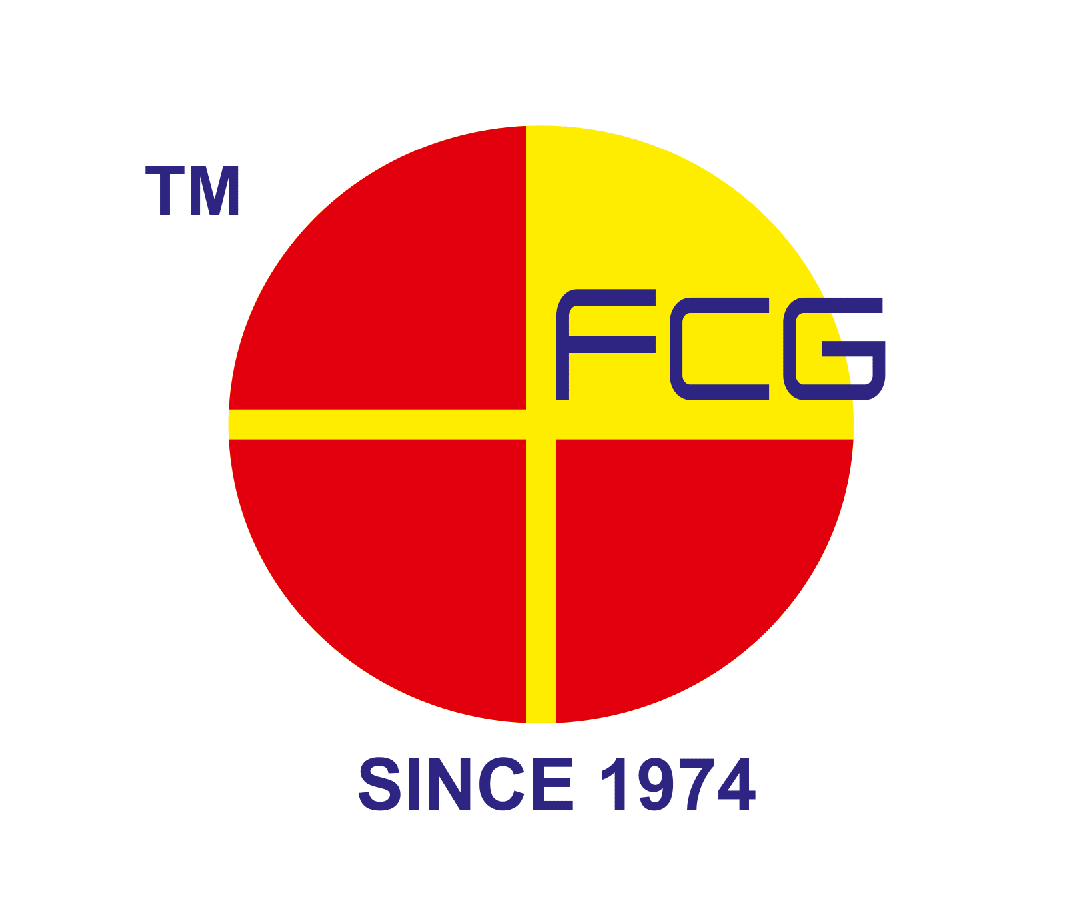











To Schedule Your Free Assessment:
- Email: sales@mygreendot.co.in,
- Phone: +91 8141042060

- Website: www.mygreendot.co.in

